WEEK-1 2520030030
U.ROHIT SAI
Step 1 — Create Database
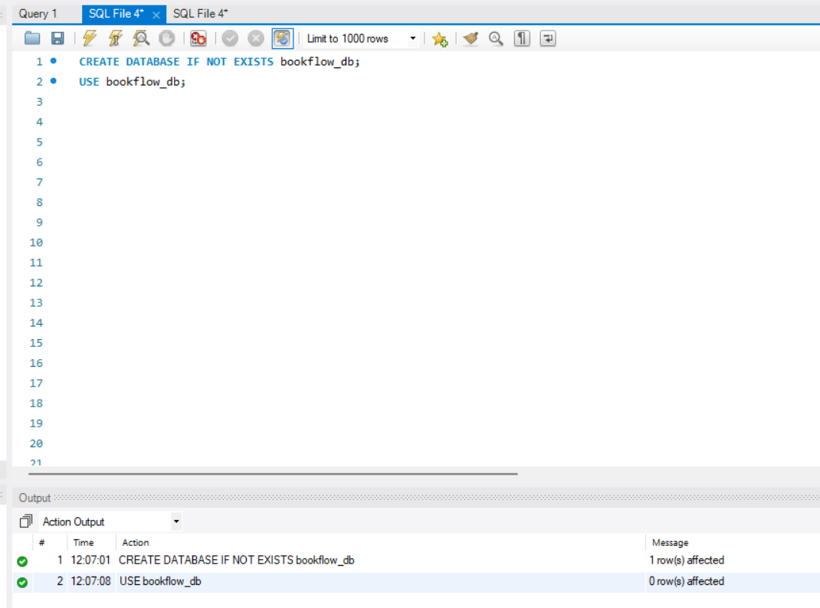
Step 2 — Create Books Table (DDL + Constraints)
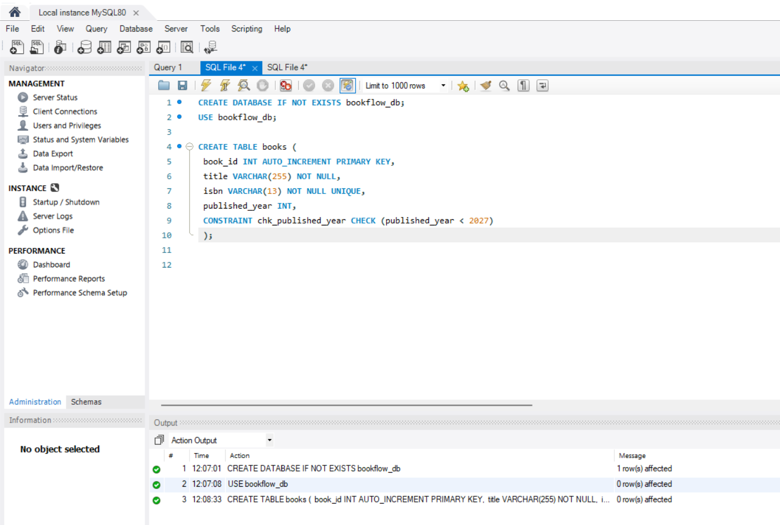

Step 3 — Insert values for Books Table and to see the table after insertion
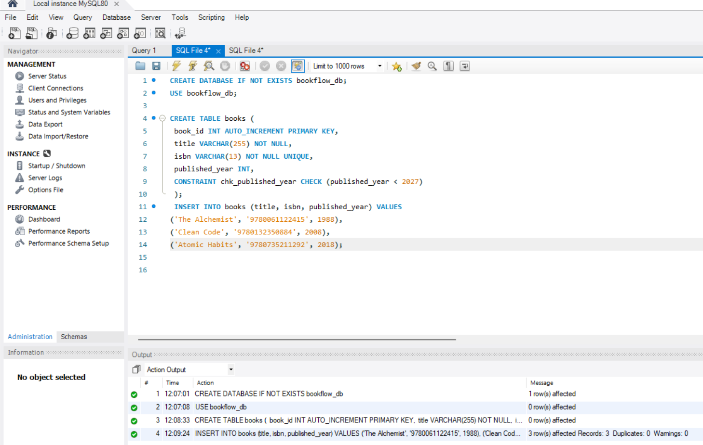

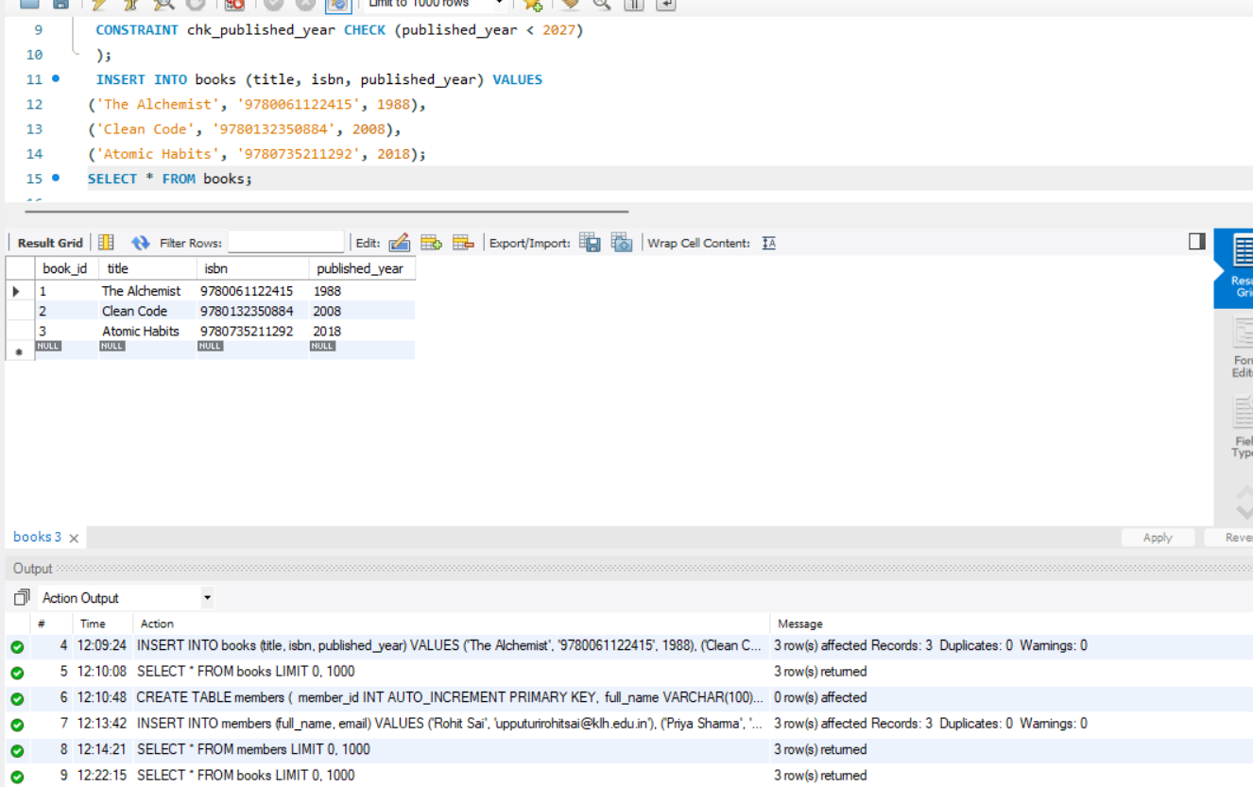
Step 4 — Create table for members

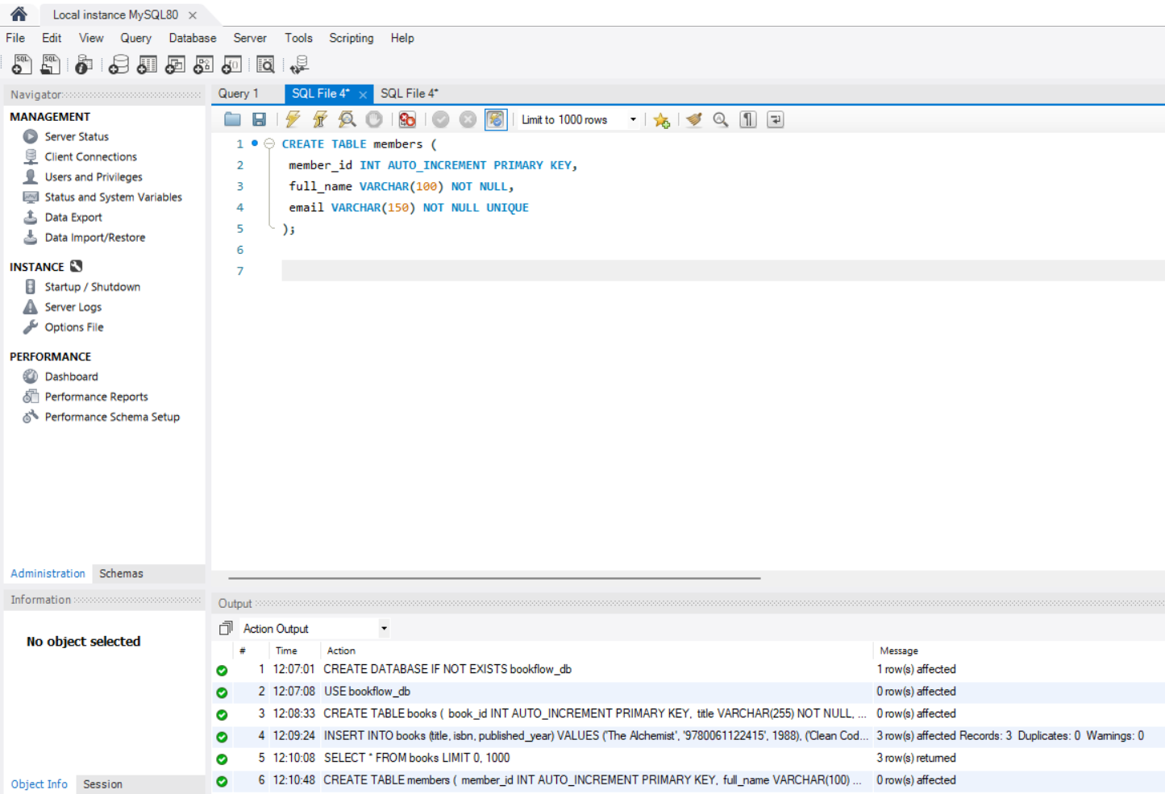

Step 5 — Inserting the values into members table and to see the table after insertion

